General Biology Year 11 2021


Unit 1 - Classification and cell processes
Task 4: Extended Response – Photosynthesis
(weighting 10%)

Name: | Teacher: | Date: | Score:  /

Conditions

Time for the task:
- Part 1: One lesson to research topic and complete notes at home.
- Part 2: One lesson for in-class validation – extended response exam style question.

Your research must be handed in or before the day of the In-class assessment to be awarded marks. You can choose the format in which you would like to present your research, as long as it is compatible for submissions i.e. iMovie, notes, PowerPoint, keynote, written and/ or typed.
A maximum of four pages if written/type and maximum of 10 slides. Research must be in your own words, not copied and pasted. List all references used.

PART 1: Research notes
Photosynthesis is the process by which plants utilise light energy and use it to break down water and carbon dioxide molecules, and build them up into glucose, oxygen and water molecules. Photosynthesis actually occurs as a series of steps in a biochemical pathway, each catalysed by specific enzymes. It requires light as an energy source that is captured by the pigment chlorophyll.
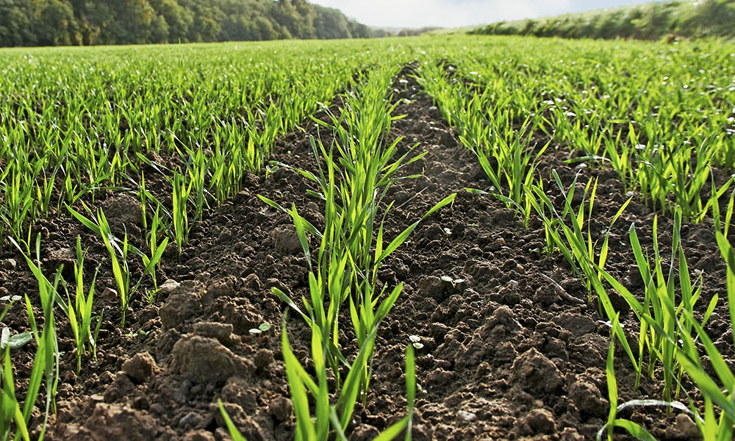
Over the past years, agricultural yields of our major crops have risen, in keeping with demand. For the most part, these increases came about due to advances in farming approaches and classical breeding that have maximised plant architecture and light capture, resulting in higher yielding varieties. Photosynthesis is the primary determinant of crop yield and the efficiency by which a crop captures light and converts it to glucose.

Maximising photosynthesis to improve commercial plant growth

Through online research from reliable sources answer the questions that follow relating to photosynthesis.

- What is the overall word equation for photosynthesis?
- Photosynthesis is the process by which plants convert three inputs into three outputs. List the three inputs.
- When any of the three inputs is limiting, the outputs are also limiting. Explain this statement.
- In which plant cell organelle does photosynthesis take place?
- What are the two stages of photosynthesis?
- Explain how the following can be a limiting factor in photosynthesis and state how conditions can be set up to reduce the effects of limiting factors:
- light
- water
- carbon dioxide
- Explain how temperature can affect the rate of photosynthesis.
- Predict at what time of the day you would expect the greatest output of oxygen from photosynthetic cells.
- The majority of plant species use C3 photosynthesis. Some plants have evolved another form of photosynthesis, C4. State the difference between the two forms of photosynthesis.
- Write a paragraph summarising how farmers can maximise photosynthesis to improve growth.

References

- I cannot claim the work or ideas of someone else as my own
- Plagiarism is not just when I directly copy words from someone else's work. Plagiarism is also when someone else's work is paraphrased or their ideas are used and claimed as my own
- Referencing has a positive effect and adds credibility to my work
- When I reference correctly, I am demonstrating that (a) I have read widely on the topic and (b) that I am supporting my hypotheses with comments from expert authors and/or reliable sources
- Correct referencing allows the marker/reader to follow-up my references and check the validity of my arguments for themselves.

In the table below, list all references used to answer the questions.

Surname | Initial | Title of page | Full title of website | Date Written | Internet Address | Date of visit
Brown | J. | ‘Things in Space’ | Astronomy Facts | 1998 | http://www.astronomyfacts.com | 31 July 2019

Note: Please submit your task through Connect (Submissions).

